CODSOFT DATA SCIENCE INTERNSHIP

PROJECT 2: IRIS FLOWER CLASSIFICATION
Submitted By: Bhawani Saini
Project Name: Iris Flower Classification
Programming Language: Python
Platform: Jupyter Notebook
Libraries: Pandas, NumPy, Matplotlib, Scikit-learn

1. Introduction
Iris Flower Classification is a machine learning project used to classify iris flowers into different species based on their measurements. The model uses sepal length, sepal width, petal length, and petal width to predict the flower species.

2. Objective
The main objective of this project is to build a machine learning model that can classify iris flowers into three species using the K-Nearest Neighbors (KNN) algorithm.

3. Dataset Description
The Iris dataset contains 150 flower samples and four numerical features.
- Sepal Length
- Sepal Width
- Petal Length
- Petal Width
The three target species are:
- Iris Setosa
- Iris Versicolor
- Iris Virginica

4. Tools and Technologies
- Python
- Jupyter Notebook
- NumPy
- Pandas
- Matplotlib
- Scikit-learn

5. Methodology
The following steps were performed in this project:
- Imported the required Python libraries.
- Loaded the Iris dataset using Scikit-learn.
- Separated the input features and target labels.
- Divided the dataset into training and testing sets.
- Trained the K-Nearest Neighbors (KNN) classification model.
- Predicted flower species using the trained model.
- Evaluated model performance using accuracy and a classification report.
- Visualized the flower species using Matplotlib.

6. Algorithm Used
K-Nearest Neighbors (KNN) is a supervised machine learning algorithm. It classifies a new data point based on the classes of its nearest data points.
In this project, KNN uses flower measurements to predict the species.

7. Model Evaluation
The K-Nearest Neighbors (KNN) model was evaluated using the test dataset.
Model Accuracy: 100.0%
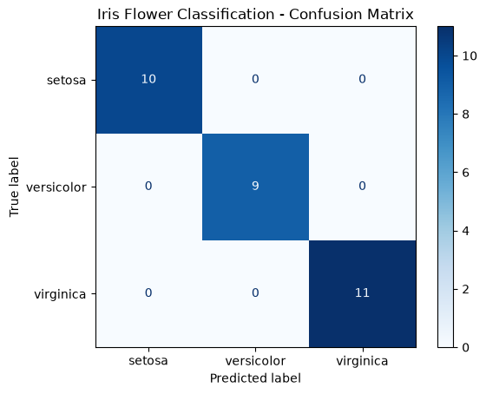
The model correctly classified all the samples in the test dataset. This result indicates excellent performance on the selected test split. However, performance may differ on other unseen datasets.

8. Visualization
A scatter plot was created using Matplotlib to visualize the three Iris flower species. The graph uses sepal length and petal length to display the samples.
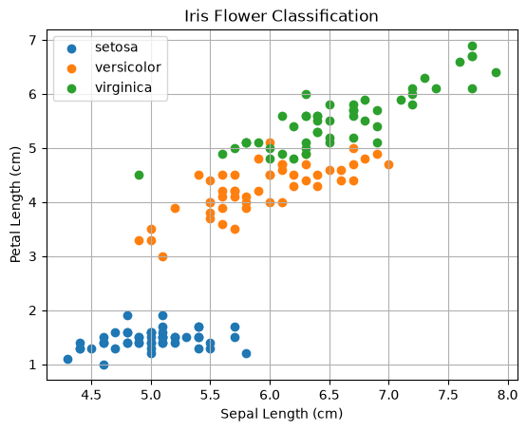

9. Result
The Iris Flower Classification model was successfully implemented using Python and the K-Nearest Neighbors (KNN) algorithm. The model achieved 100.0% accuracy on the test dataset and classified the iris flower species based on sepal and petal measurements.

10. Conclusion
This project helped demonstrate the practical application of supervised machine learning. The Iris dataset was loaded and prepared, the KNN model was trained and evaluated, and the flower species were visualized using Matplotlib. The model achieved 100.0% accuracy on the selected test split.

11. Future Scope
The project can be improved by testing different KNN parameters, comparing multiple machine learning algorithms, and evaluating their performance on unseen data.

Project Completed: Iris Flower Classification
Organization: CodSoft

